EXP NO:04 | STRING COLLECTION APPLICATION
DATE:16-08-19 | STRING COLLECTION APPLICATION
AIM:-
To create an array of strings where a string can be appended at the end,should be able to insert a string at a particular index, should be able to search for a string and sort a string with a letter starting at the first.
REQUIREMENT:-
-Should be able to append a string at the end
-should be able to insert a string at a particular index
-should be able to search for string
-should be able to sort a string with letter at first
-should be able to display the array of strings
ALGORITHM:-
STEP 1: create a package String
STEP 2: create a class named StringList
STEP 3:describe the structure of array of stings
STEP 4:Declare different cases for different conditions STEP 5:mention the case for appending a string at the end
STEP 6:mention another case for inserting a string at a particular index and display the array of strings
STEP 7:mention another case for searching a string in the array and display search result with the index value of the string if the string is in the array or else print the string is unavailable
STEP 8:mention another case for sorting a string from array with a letter at first print the string if available or else print the string is not available
STEP 9: specify the condition for executing different cases
CLASS DIAGRAM:

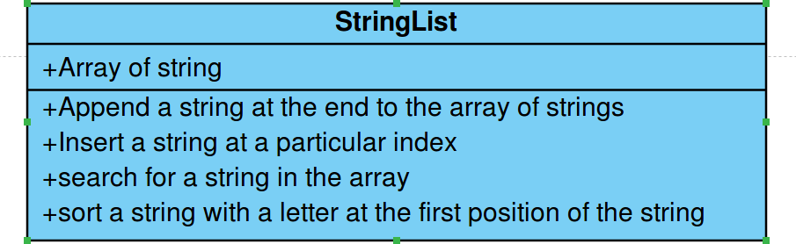
PROGRAM:
/***
*STRING COLLECTION APPLICATION
* Created by A.sandhiya
*/EEE-B
* 212217105052
*/
package String; import java.util.*;
public class StringList {
public static void main(String[] args) {
// TODO Auto-generated method stub
int option;
int index,i; String n;
Scanner sc=new Scanner(System.in); ArrayList<String> strings;
strings=new ArrayList<String>(); while(true)
{
System.out.println("1. To add a string at the end"); System.out.println("2. To insert a string at particular index"); System.out.println("3. To search for a string"); System.out.println("4. To display all the Strings");
System.out.println("5. To Display the strings starting with the given letter"); System.out.println("6. Exit");
System.out.print("Enter your choice:"); option=sc.nextInt();
switch(option)
{
case 1:
System.out.print("Enter a String:"); n=sc.next();
strings.add(n);
System.out.println("The given string is added at the end"); break;
case 2:
System.out.print("Enter a string:"); n=sc.next();
System.out.print("Enter the index:"); index=sc.nextInt(); strings.add(index,n);
System.out.println("The given string is added at the given index"); break;
case 3:
System.out.print("Enter a strings:"); n=sc.next(); index=strings.indexOf(n); if(index<0)
{
System.out.println("The given strings is not available in the list");
}else
{
System.out.printf("The strings %s is found at the index %s\n",n,index);
}
break; case 4:
System.out.println("The available numbers are:"); for(i=0;i<strings.size();i++)
{
System.out.println(strings.get(i));
}
break; case 5:
System.out.println("Enter the first letter character"); n=sc.next();
for(i=0;i<strings.size();i++)
{
if(strings.get(i).startsWith(n))
{
System.out.println(strings.get(i));
}
}
break; case 6:
System.out.println("Thankyou for using strings list application !!!"); break;
default:
System.out.println("Please enter a valid choice !!!");
}
if(option==6)
{
break;
}
}
}
}
OUTPUT:
- To add a string at theend
- To insert a string at particularindex
- To search for astring
- To display all theStrings
- To Display the strings starting with the givenletter
- Exit
Enter your choice:1 Enter a String:uday
The given string is added at the end
- To add a string at theend
- To insert a string at particularindex
- To search for astring
- To display all theStrings
- To Display the strings starting with the givenletter
- Exit
Enter your choice:2 Enter a string:hari Enter the index:0
The given string is added at the given index
- To add a string at theend
- To insert a string at particularindex
- To search for astring
- To display all theStrings
- To Display the strings starting with the givenletter
- Exit
Enter your choice:5
Enter the first letter character u
uday
- To add a string at theend
- To insert a string at particularindex
- To search for astring
- To display all theStrings
- To Display the strings starting with the givenletter
- Exit
Enter your choice:6
Thankyou for using strings list application !!!

RESULT:-
Hence, A java program is created for string collection application where string can be added to an array,
a string can be inserted at particular index in the array, a string can be searched, a string can be sorted from array with a letter at first place in thye string.

